Day-3

1.Creating a ubuntu virtual machine:

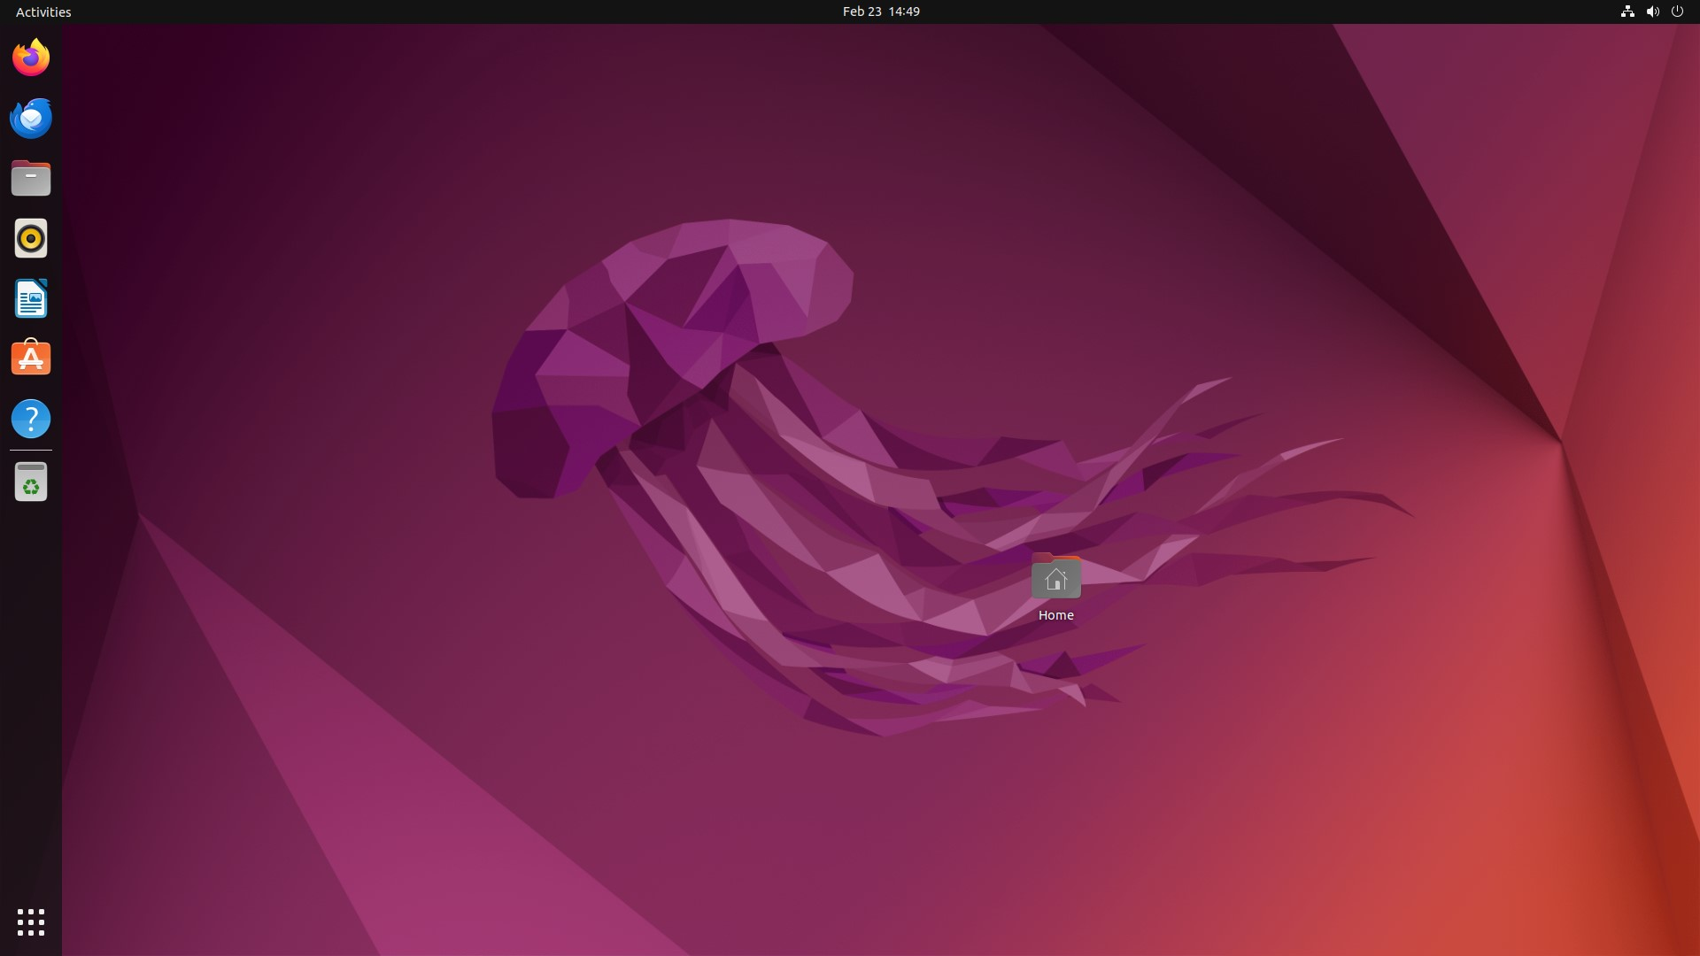

2.Configuring the memory ( 1 CPU, 2GB RAM and 15GB storage):

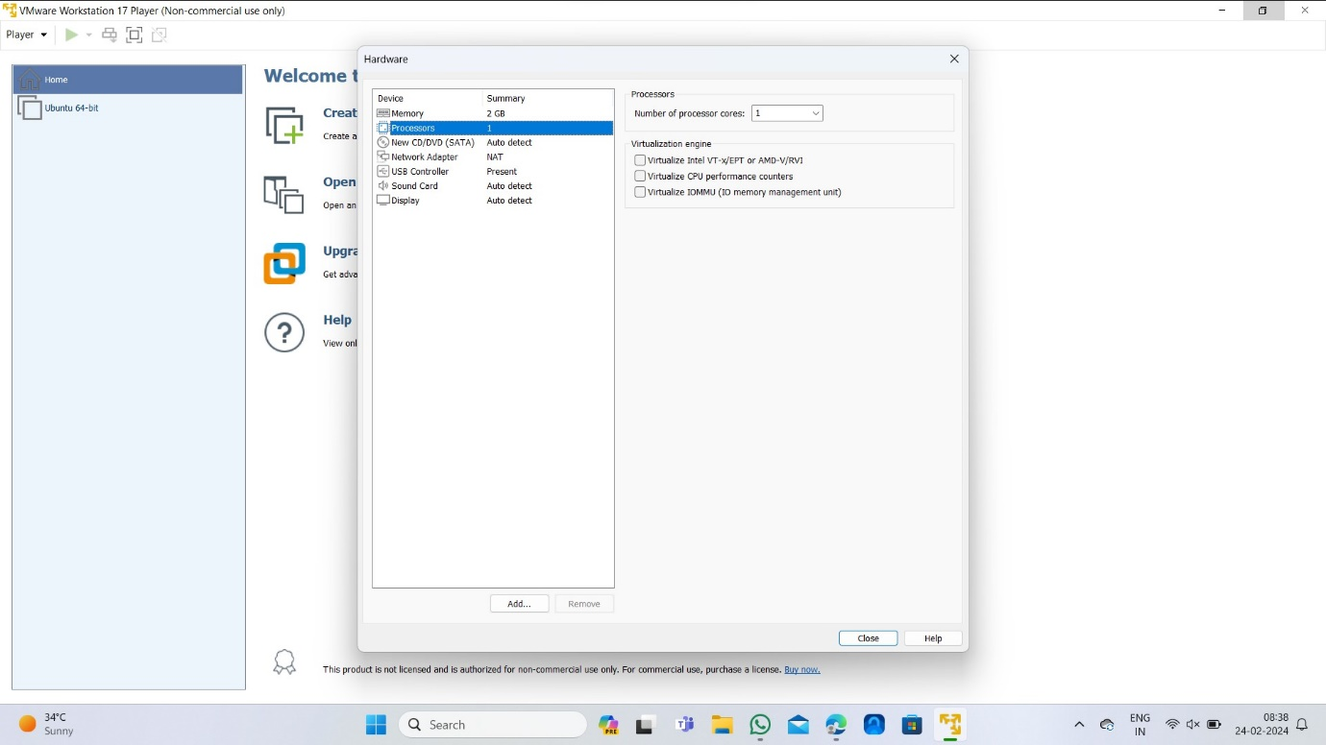

3.creating a virtual hard disk:

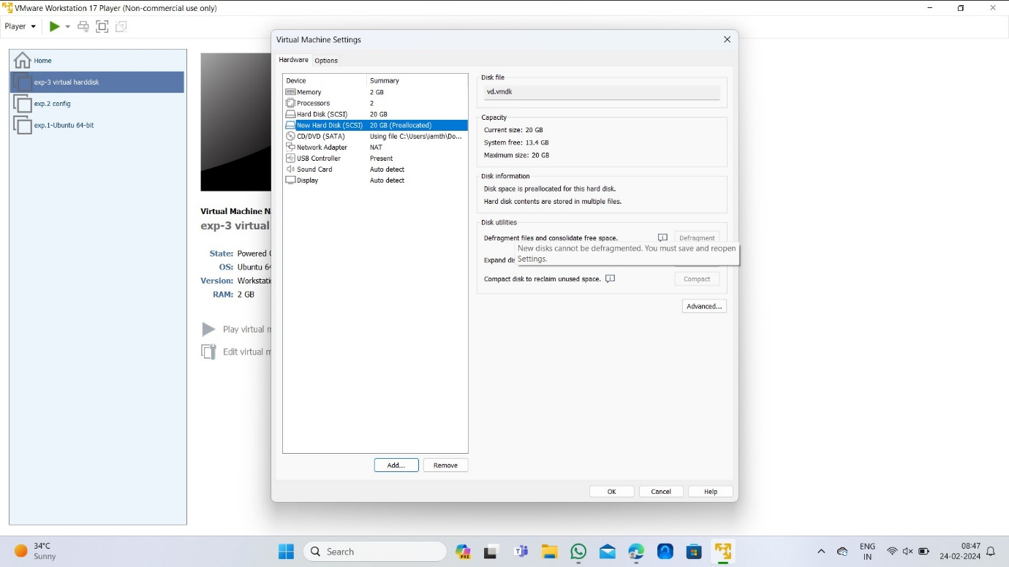

4.Taking a snapshot:

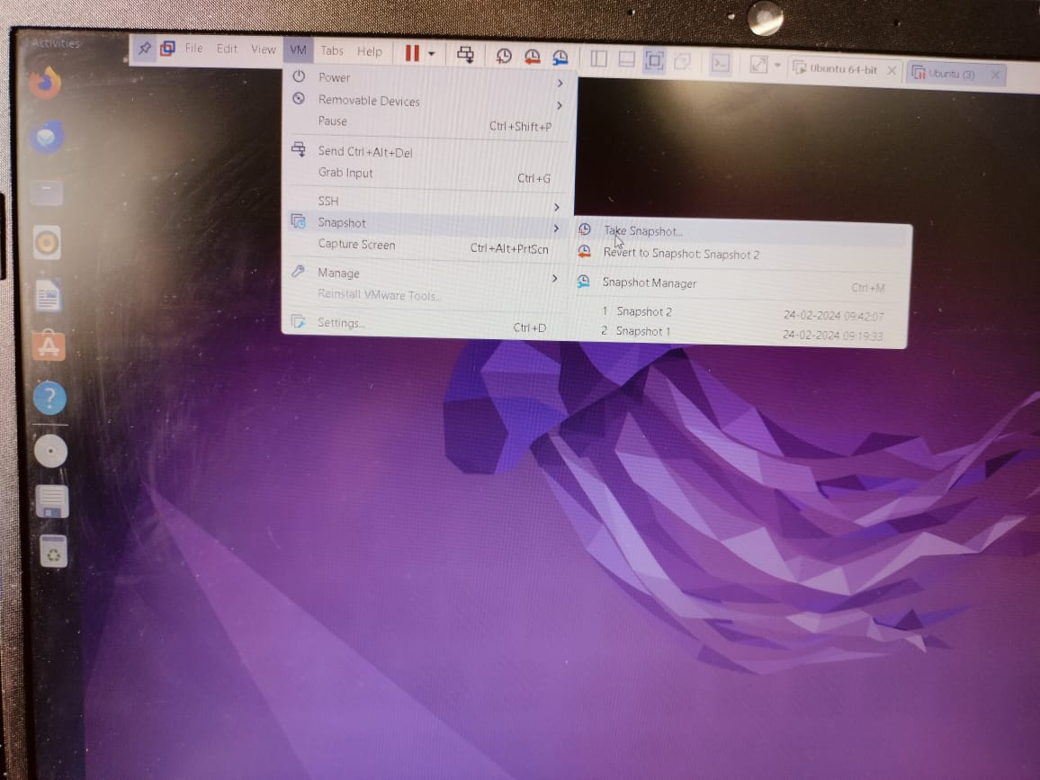

5.creating a clone virtual machine:

